**Advance Database Management Systems**

**Experiment- 4**

**Use of built-in functions and relational algebra operations.**

create database LabExperiment4;

USE LabExperiment4;

create table DEPT(DEPTNO INT, DNAME VARCHAR(30), LOC VARCHAR(45), PRIMARY KEY(DEPTNO));

INSERT INTO DEPT VALUES(10, 'ACCOUNTING', 'NEW YORK');

INSERT INTO DEPT VALUES(20, 'RESEARCH', 'DALLAS');

INSERT INTO DEPT VALUES(30, 'SALES', 'CHICAGO');

INSERT INTO DEPT VALUES(40, 'OPERATIONS', 'BOSTON');

create table EMP(EMPNO int not null, ENAME varchar(45) NOT NULL, JOB varchar(30) NOT NULL, MGR INT, HIREDATE DATE, SAL INT, COMM INT, DEPTNO INT NOT NULL, PRIMARY KEY (EMPNO), FOREIGN KEY(DEPTNO) REFERENCES DEPT(DEPTNO));

INSERT INTO EMP VALUES(7369, 'SMITH', 'CLERK', 7902, '17-DEC-80', 500, 800, 20);

INSERT INTO EMP VALUES(7499, 'ALLEN', 'SALESMAN', 7698, '20-DEC-81', 1600, 300, 30);

INSERT INTO EMP VALUES(7521, 'WARD', 'SALESMAN', 7698, '22-FEB-81', 1250, 500, 30);

INSERT INTO EMP VALUES(7566, 'JONES', 'MANAGER', 7839, '02-APR-81', 2975, '', 20);

INSERT INTO EMP VALUES(7654, 'MARTIN', 'SALESMAN', 7698, '28-SEP-81', 1250, 1400, 30);

INSERT INTO EMP VALUES(7698, 'BLAKE', 'MANAGER', 7839, '01-MAY-81', 2850, '', 30);

INSERT INTO EMP VALUES(7782, 'CLARK', 'MANAGER', 7839, '09-JUN-81', 2450, '', 10);

INSERT INTO EMP VALUES(7778, 'SCOTT', 'ANALYST', 7566, '09-DEC-82', 3000, '', 20);

INSERT INTO EMP VALUES(7839, 'KING', 'PRESIDENT', '', '17-NOV-81', 5000, '', 10);

INSERT INTO EMP VALUES(7844, 'TURNER', 'SALESMAN', 7698, '03-SEP-81', 1500, '', 30);

INSERT INTO EMP VALUES(7876, 'ADAMS', 'CLERK', 7788, '12-JAN-83', 1100, '', 20);

INSERT INTO EMP VALUES(7900, 'FORD', 'ANALYST', 7566, '03-DEC-81', 3000, '', 20);

INSERT INTO EMP VALUES(7934, 'MILLER', 'CLERK', 7782, '23-JAN-82', 1300, '', 10);

-- List the details of the emps whose Salaries more than the employee BLAKE.

SELECT * from EMP WHERE SAL > (SELECT SAL from EMP where ENAME='Blake');

OUTPUT:

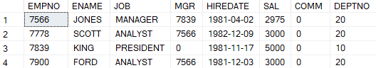

-- List the emps whose Jobs are same as ALLEN.

SELECT * from EMP WHERE JOB = (SELECT JOB from EMP where ENAME='Allen');

OUTPUT:

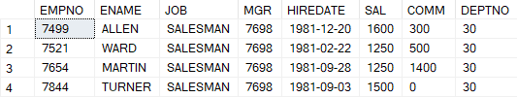

-- List the Emps whose Sal is same as FORD or SMITH in desc order of Names.

SELECT * from EMP WHERE SAL = (SELECT SAL from EMP where ENAME='Ford') OR SAL = (SELECT SAL from EMP where ENAME='Smith') ORDER BY ENAME DESC;

OUTPUT:

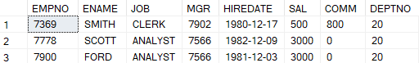

-- List the emps Whose Jobs are same as MILLER or Sal is more than ALLEN.

SELECT * FROM EMP WHERE JOB = (SELECT JOB FROM EMP WHERE ENAME='Miller') OR SAL > (SELECT SAL FROM EMP WHERE ENAME='Allen');

OUTPUT:

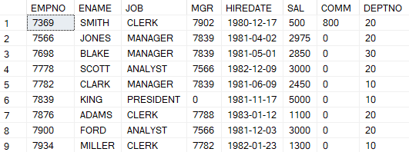

-- Find the highest paid employee of sales department.

SELECT * FROM EMP WHERE DEPTNO = 30 AND SAL = (SELECT MAX(SAL) FROM EMP WHERE DEPTNO = 30);

OUTPUT:



-- List the employees who are senior to most recently hired employee working under king.

SELECT * FROM EMP WHERE HIREDATE < (SELECT MAX(HIREDATE) FROM EMP WHERE MGR = (SELECT EMPNO FROM EMP WHERE ENAME='King'));

OUTPUT:

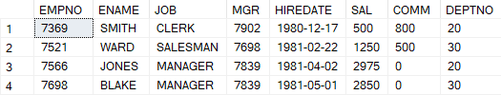

-- List the names of the emps who are getting the highest sal dept wise.

SELECT E.ENAME, D.DNAME, E.SAL FROM EMP E JOIN DEPT D ON E.DEPTNO = D.DEPTNO WHERE E.SAL = (SELECT MAX(SAL) FROM EMP WHERE DEPTNO = E.DEPTNO) GROUP BY E.ENAME, D.DNAME, E.SAL ORDER BY D.DNAME;

OUTPUT:

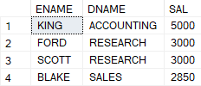

-- List the emps whose sal is equal to the average of max and minimum

SELECT ENAME, SAL, JOB FROM EMP WHERE DEPTNO = 10 AND SAL = (SELECT MAX(SAL) FROM EMP WHERE DEPTNO = 10) OR DEPTNO = 20 AND SAL = (SELECT MAX(SAL) FROM EMP WHERE DEPTNO = 20) OR DEPTNO = 30 AND SAL = (SELECT MAX(SAL) FROM EMP WHERE DEPTNO = 30) OR DEPTNO = 40 AND SAL = (SELECT MAX(SAL) FROM EMP WHERE DEPTNO = 40);

OUTPUT:

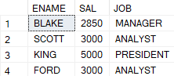

-- List the emps who joined in the company on the same date.

SELECT ENAME, HIREDATE FROM EMP GROUP BY HIREDATE, ENAME HAVING COUNT(*) > 1;

OUTPUT:



-- Find out the emps who joined in the company before their Managers.

SELECT * FROM EMP E WHERE HIREDATE < (SELECT HIREDATE FROM EMP WHERE EMPNO = E.MGR);

OUTPUT:

